# Amazon Product Review Analysis

By: Olabisi

Date: July 2025

## 1. Dataset Overview

- Records: 1,465 products

- Fields: category, price, discount, rating, review count, etc.

## 2. Key Insights

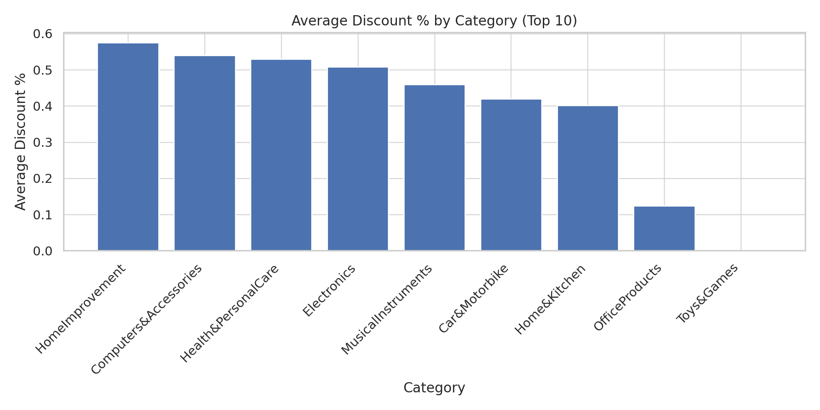

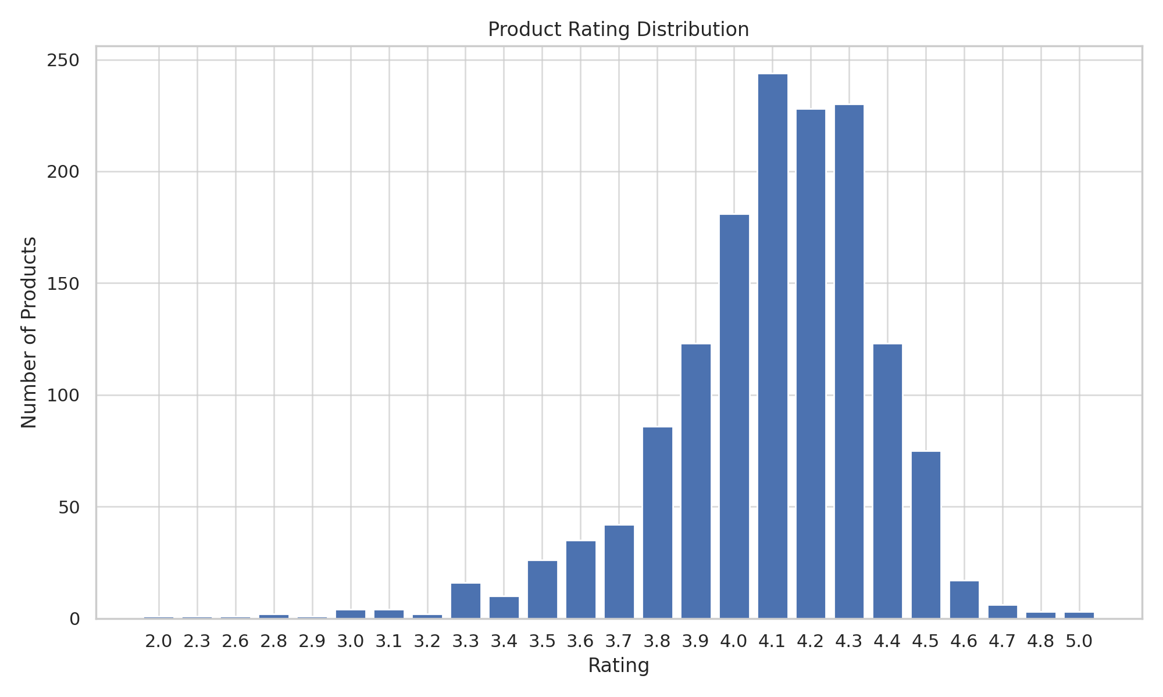

- Products with ≥50% discount: 751

- Products with <1,000 reviews: 326

- Correlation between rating and discount: -0.16

## 3. Top Findings

- Categories with highest average discounts concentrate in Accessories & Peripherals.

- Highest potential revenue comes from Audio Products category (headphones, speakers, etc.).

- Discount level shows weak correlation with product rating.

## 4. Conclusion

These insights can guide marketing strategies, discount planning, and inventory prioritization.